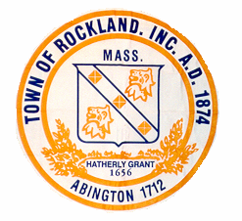
TOWN OF ROCKLAND
Town Clerk’s Office
242 Union Street
Rockland, MA 02370
Tel: (781) 871-1874 Fax: (781) 871-0386
email: clerkdept@rockland-ma.gov

Welcome!

We received information that you recently bought a house in Rockland, so we’d like to welcome you to Town. Our office is enclosing a census form so we can record all the members of your family. Our figures are recorded with the school, fire and police departments, so there is an accurate count for each address. Dog information can be found on the back of the census. If you have a dog, they can be licensed in the Town Clerk’s office. Dogs need to be licensed every year. We’ve also included voter registration forms.
You can return our information in the enclosed envelope, which can be mailed, dropped off during the day or placed in the drop box to the left of the front door after hours. We are located on Union Street, across from the Rockland Federal Credit Union.
We hope you’ll enjoy your new home in Rockland. If you have any questions, please feel free to call or drop in. Town hall is open Monday- Friday 8:30-4:30, and the 1st and 3rd Tuesday nights until 8:00 from September through June. In July and August, we don’t have late night hours and we’re closed on Fridays.
We have a Veteran’s agent, Recreation and Senior Center as well as many boards and committees in Rockland. If you’re interested in finding out more about our town, our website is www.rockland-ma.gov or we can be googled under -Town of Rockland MA.
Once again, we in the Town Clerk’s Office would like to say “Welcome!”
Sincerely,
Town Clerk’s Office

