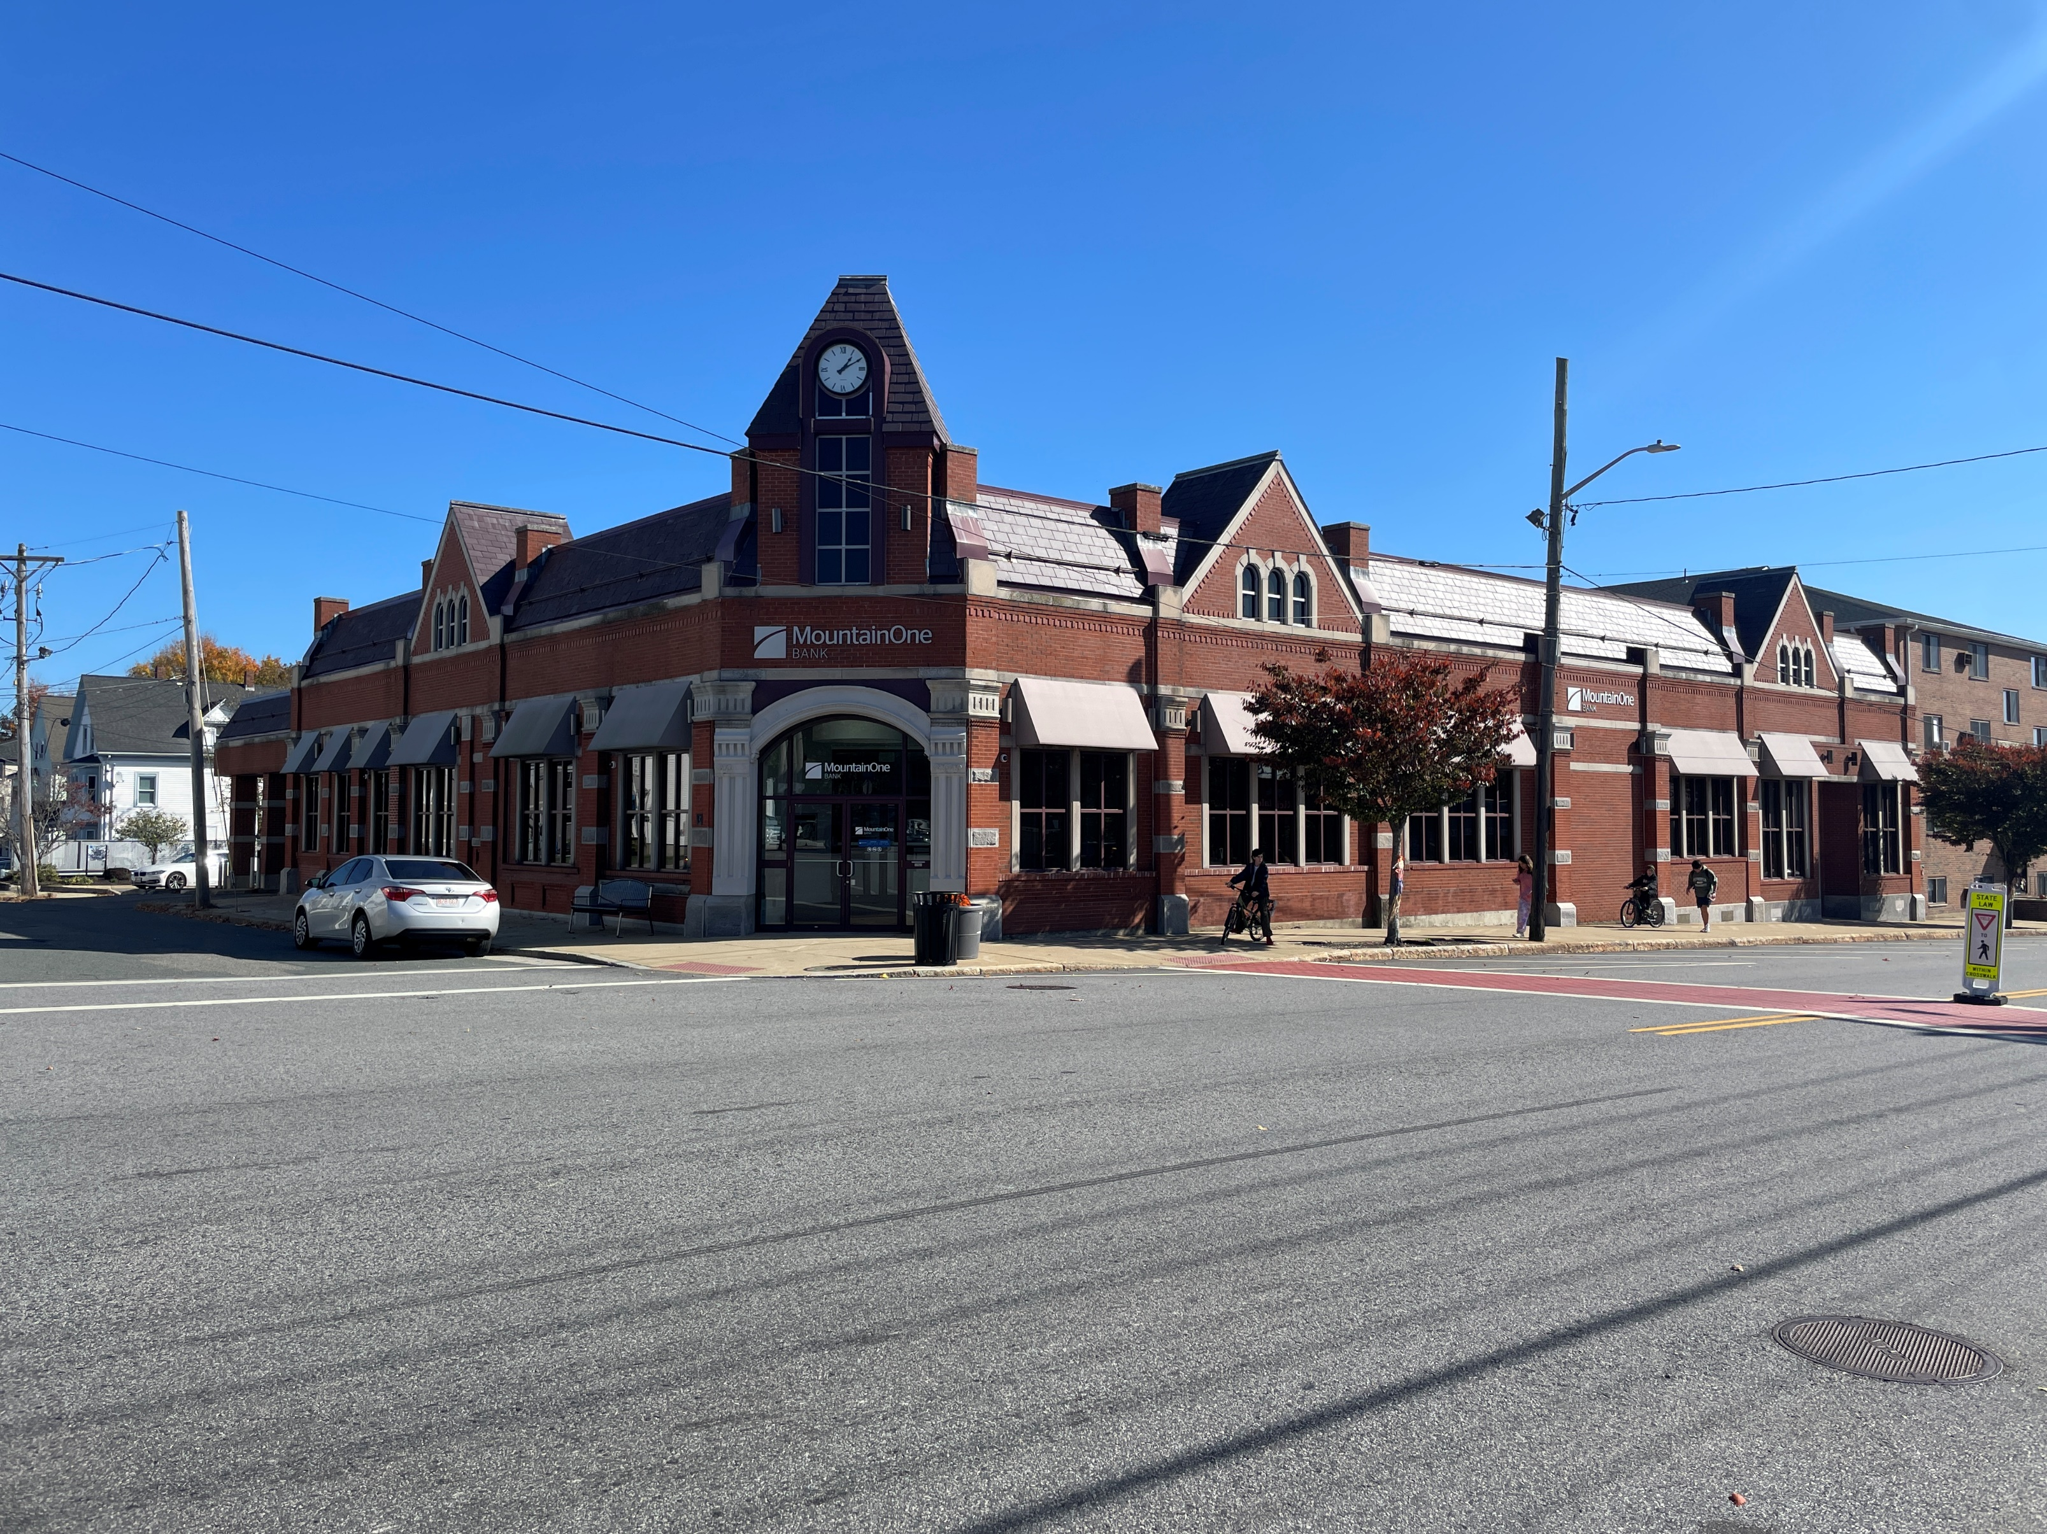

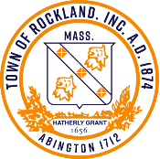
Town of Rockland
Façade & Sign Improvement Program

Rockland Facade & Sign Improvement
Grant Program Application

Applicant Information
CHECK ONE: | BUILDING OWNER | TENANT
APPLICANT NAME:
MAILING ADDRESS:
CITY: | STATE: | ZIP:
EMAIL: | BUSINESS PHONE: | MOBILE PHONE

Grant Information
BUSINESS NAME OR BUILDING NAME:
TYPE OF BUSINESS |  | NUMBER OF COMMERCIAL TENANT SPACES WITHIN THE BUILDING:
BUSINESS ADDRESS:
CITY: | STATE: | ZIP:
GRANT LEVEL (1, 2, 3, OR 4)
GRANT AMOUNT REQUEST

Proof of property owner’s permission for the project is required. Complete the section below if applicant is not also property owner. Property owner can sign below to indicate their permission OR you may attach written proof of permission from property owner.

Property Owner Information
PROPERTY OWNER:
OWNER’S MAILING ADDRESS:
CITY: |  | STATE: | ZIP:
EMAIL: | PHONE:
PRINT PROPERTY OWNER NAME:  (IF APPLICANT IS NOT ALSO OWNER) |  |  | TITLE:
PROPERTY OWNER’S SIGNATURE:  (IF APPLICANT IS NOT ALSO OWNER) |  |  | DATE:

Project Information and Scope of Work Template
PROPERTY ADDRESS:
BUSINESS OR PROPERTY OWNER NAME:
BUSINESS NAME (IF APPLICABLE):
ESTIMATED TIME FRAME FOR PROJECT COMPLETION:

Project Description
Please describe how your project supports the Façade and Sign Improvement Program objectives and enhances the appearance and business environment of downtown Rockland.

Scope of Work
Check the type(s) of improvement you plan to make:
☐ | Painting | ☐ | Door/Windows | ☐ | Landscape
☐ | Signage | ☐ | Masonry/Siding | ☐ | Mural
☐ | Awning | ☐ | Total Facade | ☐ | Other
☐ | Lighting | ☐ | Accessibility
Use the space below to provide information on any proposed project improvements and attach any supplementary information (e.g., photos of existing conditions, contractor estimates, drawings, colors, and material samples).
Improvement | Description | Estimated Cost
Total

Certification and Signature
I, the undersigned, certify that all information presented is truthful and accurate, to the best of my knowledge and belief. I hereby accept and agree to all terms and conditions presented above. I understand that grant funds applied for under this program must be used for the project described above. I further understand that the Town of Rockland reserves the right to reject any or all grant applications and to waive informalities.
Print Applicant Name:
Applicant’s Signature: | Date:

Submit completed application and all supporting documents to:
Rockland Town Offices
c/o Planning Department
242 Union Street
Rockland, MA 02370

Property Owner Authorization Form

Instructions: If you are a business owner (tenant) applying for funding, please have the property owner complete and sign the following letter and submit this with your Application and sign the first page of the Application Form.

Date:

I acknowledge that the tenant, (name of applicant), in my building located at (street address), doing business as (name of business) is applying to participate in the Town of Rockland Façade & Sign Improvement Program.
I have read the terms and conditions applying to this program, and the improvements proposed by the tenant, and authorize this tenant to pursue participation in this program.

Signed,
Print Name
Property Address
Signature

