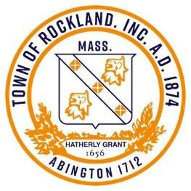
MEETING NOTICE POSTING
TOWN CLERK’S STAMP
& AGENDA

TOWN OF ROCKLAND

Pursuant to MGL Chapter 30A, §18-25, all Meeting Notices must be filed, and time stamped in the Town Clerk’s Office and posted at least 48 hours prior to the meeting (excluding Saturdays, Sundays and Holidays). Please be mindful of the Town Clerk’s business hours of operation and make the necessary arrangements to ensure this Notice is received and stamped in by the Town Clerk’s Office and posted by at least 30 minutes prior to the close of business on the day of filing.

Board or Committee | Open Space Committee
Date & Time of Meeting | Monday, January 13, 2025 @ 6:30 pm
Meeting Location:  or  Remote Information: | Town Hall, Lower Meeting Room (Chaffee)
Meeting Location:  or  Remote Information: | Meeting ID: | Passcode:
Requested By: | Donald Cann, Chairman
# OF PAGES (including cover sheet) 1 REVISED ☐ Yes ☐ No

Agenda

Minutes

Administration

Questions regarding new instructions to the OSC from the BOS

Update of the of Rockland’s Open Space and Recreation Plan

Finalizing acquisition of land parcels that were previously acquired and not recorded

Update on Camp Alice Carleton, Whitman/Rockland

The former South Weymouth Naval Air Station.
MEPA Certificate
Union Point Amenities Plan

Updates on 1119 Union Street

Explorer the idea of forming an open space organization with our neighboring towns.

The 2024 Annual OSC Report

Business that may come before the committee that was anticipated by the chair

